# Exercise 1: ERD

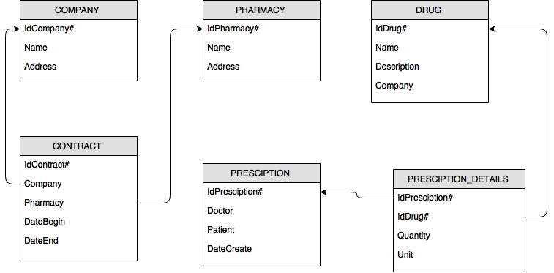

# Exercise 2: Database

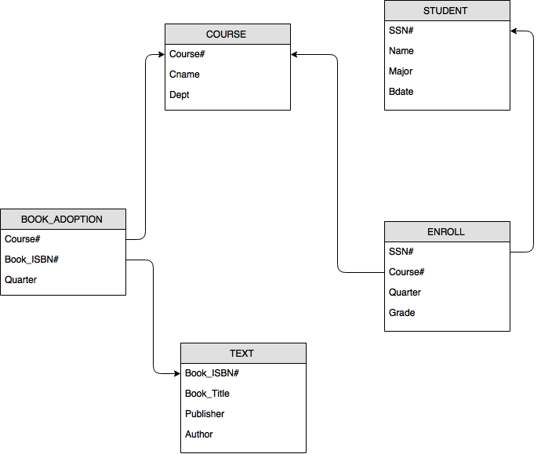

# Exercise 3: Data Types

|  |  |  |
| --- | --- | --- |
| Column | Description | Type |
| ID | Primary Key of the table, each time a record is inserted into the table this column is incresed by 1. | Char(6) |
| Name | A string in English | Varchar(25) |
| Code | An alphanumeric code that has five characters | Char(5) |
| ModifiedDate | The datetime of the last modification. | Date |

# Exercise 4: Data Types (2)

|  |  |  |
| --- | --- | --- |
| Column | Description | Type |
| ID | Primary Key of the table, each time a record is inserted into the table this column is incresed by 1. | int |
| Name | A string in any language. | Varchar(25) |
| BirthDate | Date of birth | Date |
| Gender | Integer, 0: Male, 1: Female, NULL: Unknown | bit |
| IsDeletedFlag | 0 means active, 1 means deleted. | bit |